Bootstrap Demo

Main Page of Demo with more example than I showed.

<http://www.tutorialrepublic.com/twitter-bootstrap-tutorial/bootstrap-responsive-layout.php>

# Bootstrap tables

Code and demo

<http://www.tutorialrepublic.com/codelab.php?topic=bootstrap&file=simple-table>

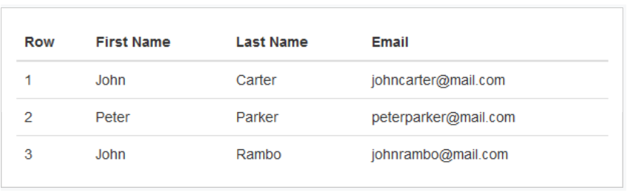

And show my Code in Ultra Edit in Templates <Table Bootstrap

**Bootstrap Input Groups**

[**http://www.tutorialrepublic.com/codelab.php?topic=bootstrap&file=prepended-and-appended-inputs-02**](http://www.tutorialrepublic.com/codelab.php?topic=bootstrap&file=prepended-and-appended-inputs-02)

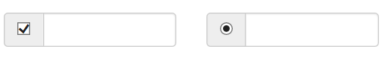

<http://www.tutorialrepublic.com/codelab.php?topic=bootstrap&file=button-dropdowns>

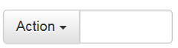

And show my Code in Ultra Edit

# Bootstrap List Groups

<http://www.tutorialrepublic.com/codelab.php?topic=bootstrap&file=list-group>

<http://www.tutorialrepublic.com/codelab.php?topic=bootstrap&file=list-group-with-linked-items>

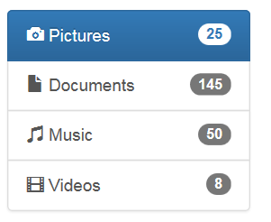 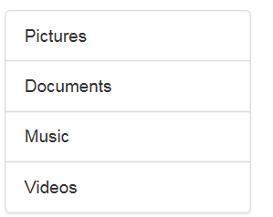

**Bootstrap Progress Bar with Label**



<http://www.tutorialrepublic.com/codelab.php?topic=bootstrap&file=basic-progress-bar-with-label>

# Bootstrap Modals

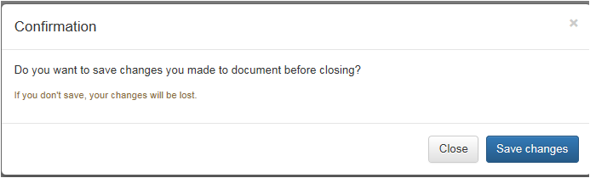

**Code and Demo**

[**http://www.tutorialrepublic.com/codelab.php?topic=bootstrap&file=modal**](http://www.tutorialrepublic.com/codelab.php?topic=bootstrap&file=modal)